 | FPT ACADEMY INTERNATIONAL  FPT – APTECH COMPUTER EDUCATION
Centre Name: ACE-THUDUC-1-FPT
Address: 391A Nam Ky Khoi Nghia, District 3, Ho Chi Minh City, Viet Nam.

MayPay HR

Group 2

Supervisor:
Term: | 4
Batch No: | T1.2311.M0
Group No: | 2
Order: | Full name | Roll No.
1. | Bùi Công Tú | Student1531954
2. | Trần Thị Cẩm Tiên | Student1501742
3. | Nguyễn Thiên Phú | Student1531953
4. | Dương Đông Nhi | Student1531943
Duration: | Start date:
 | End date:

Acknowledgement
As we understand, the eProject is a structured, step-by-step learning environment that effectively simulates classroom and lab-based learning, transitioning academic knowledge into practical application. It offers a hands-on experience that brings the learning process to life on our devices. Through this project, we were able to:
✓ Practice using a laddered approach, progressing step by step.
✓ Build a more complete and sophisticated application.
✓ Apply specific utilities in user-designed applications.
✓ Integrate individual programs into a cohesive, functional system.
✓ Learn implementation of key concepts in a staged and manageable manner.
✓ Enhance our technical skills and personal value.
✓ Engage with real-life projects and situations.
✓ Tackle realistic scenarios that foster the development of complex and practical solutions.
✓ Benefit from valuable mentoring and guidance through email support.
We extend our sincere gratitude to our professor and fellow classmates for their continued support and encouragement throughout this project. Although we encountered challenges and made a few mistakes during the development process, we view these experiences as stepping stones for further learning in the world of web development.
We also deeply appreciate the resources and demo project provided by APTECH India, which offered us a clearer perspective and a more immersive experience. This project has greatly contributed to our growth, and we are motivated to continue learning and improving our skills as we move forward toward future success.
Yours sincerely,
Team Group 02

Synopsis
The objective of this eProject is to provide students with a practical opportunity to work on a real-life application, bridging the gap between theoretical knowledge and practical implementation. This project allows learners to develop a more robust and comprehensive application, reflecting real-world development scenarios.
Rather than focusing on direct instruction, this eProject is designed to immerse students in a realistic environment where they can apply their knowledge of tools and technologies, particularly in the context of ReactJS. It serves as a platform to reinforce concepts learned during the module and put them into meaningful practice.
Before starting the project, students are encouraged to revisit relevant chapters and concepts to ensure a solid foundation. The project is intended to be completed during lab sessions, where faculty assistance is available if needed.
A clear understanding of the subject matter is essential to successfully complete the project. Students are expected to follow the project guidelines and solve assignments as per the requirements provided.
For any queries or clarifications regarding the project objectives or implementation, students are advised to reach out to the eProjects Team for guidance and support.

Chapter 1. Problem Definition
In today’s increasingly competitive manufacturing sector-especially within garment factories-businesses face significant challenges in managing their workforce effectively. As production demands rise and order cycles become shorter, factory owners and managers must coordinate employee attendance, salary calculation, leave requests, and daily operations with a high level of accuracy and efficiency. However, many small and medium-sized garment workshops still rely on manual processes such as paper-based attendance sheets, handwritten salary calculations, or basic Excel files, which are prone to errors, delays, and data inconsistencies.
Traditional workforce management methods not only consume valuable time but also lack transparency, often resulting in disputes over payroll, inaccurate attendance records, and difficulties in monitoring employee performance. Additionally, the absence of a centralized system makes it challenging for managers to track real-time information, approve leave requests promptly, or forecast workforce needs. Employees themselves may struggle to access their attendance history, salary breakdown, or leave balances, leading to confusion and reduced satisfaction.
Recognizing these challenges, this project introduces a comprehensive Employee Management System tailored specifically for garment workshops. The solution integrates both a React-based web application for administrators and a mobile application for employees. The platform aims to streamline attendance tracking, automate payroll calculation, simplify leave management, and enhance communication between workers and management. By providing an efficient and user-friendly digital ecosystem, the system seeks to improve operational productivity, reduce administrative burden, and support more transparent and accurate workforce management.

Chapter 2. Design Requirements Specification

2.1 Project Objective
The primary objective of this project is to provide a practical, real-world development experience focused on workforce management within a garment workshop environment. Rather than limiting the project to a single type of functionality, the system aims to address the core operational challenges faced by manufacturing businesses-specifically the need for accurate attendance tracking, transparent payroll calculation, and efficient leave management.
The system is designed to streamline administrative processes, reduce manual errors, and improve communication between employees and management. It also ensures that both administrators and workers have access to clear, real-time information through web and mobile platforms.
This includes:
- Employee attendance tracking through a digital check-in/check-out system.
- Automated payroll calculation based on working hours, overtime, leave deductions, and predefined salary structures.
- Leave management module allowing employees to request leave and managers to approve or reject requests.
- Employee profile and contract management including personal details, work history, and position data.
- Shift scheduling to help managers allocate manpower efficiently.
- Mobile access for workers to view attendance records, salary breakdowns, and leave status.
- Web-based administrative dashboard for managers to oversee operations, generate reports, and make data-driven decisions.

2.2 Technology Stack
This project follows the approved development guidelines and combines both web and mobile technologies to deliver a complete workforce management solution.
Frontend (Web Application)
- React.js - For building dynamic, component-based user interfaces.
Mobile Application
- Flutter
Backend
- Spring Boot
Database
- MySQL 8.0 - For managing employee data, attendance logs, payroll records, and leave information.
Additional Tools & Services
- JWT Authentication - For secure login and role-based access control.
- RESTful API design - For communication between the web/mobile clients and backend server.
- Git & GitHub - For version control and collaboration.

Task Sheet Review 1
Project Ref No. |  | Project Title | Activity Plan Prepared by | Date of preparation of Activity Plan
Sr. No. | Task |  |  | Actual Start Date | Actual Days | Teammate Names | Status
1 | Acknowledgment | MayPayHR | Tu, Tien, Nhi, Phu | 18/11/2025 | 2 days | Nhi | Completed
2 | Introduction |  |  | 18/11/2025 | 2 days | Nhi | Completed
3 | Problem Definition |  |  | 18/11/2025 | 2 days | Nhi | Completed
4 | Design Requirement Specification |  |  | 18/11/2025 | 1 day | Nhi | Completed
5 | Scope of Work |  |  | 18/11/2025 | 2 days | Nhi | Completed
6 | Hardware/Software Requirement |  |  | 18/11/2025 | 1 day | Nhi | Completed
7 | Task Sheet |  |  | 18/11/2025 | 2 days | Nhi | Completed
8 | Architecture and design of the project |  |  | 18/11/2025 | 1 day | Nhi | Completed

Chapter 3. Database Design

3.1 Relational Model of Database
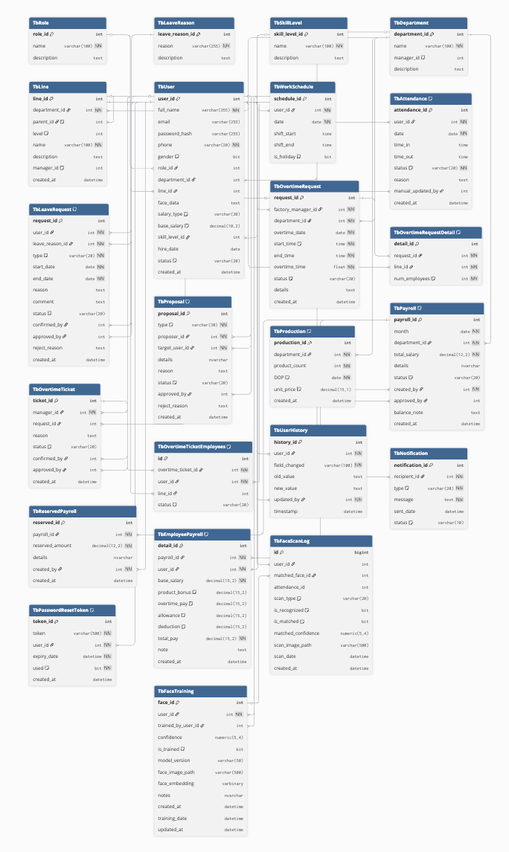

3.2 Data Description of Tables
1. TbRole
Field Name | Data Type | Key | Description
role_id | int | PK | Auto-increment unique identifier for each role
name | varchar(100) | Unique | Role name
description | text |  | Description of the role

2. TbLeaveReason
Field Name | Data Type | Key | Description
leave_reason_id | int | PK | Auto-increment unique identifier for leave reason
reason | varchar(255) |  | The reason for leave
description | text |  | Additional explanation

3. TbSkillLevel
Field Name | Data Type | Key | Description
skill_level_id | int | PK | Unique skill level identifier
name | varchar(100) |  | Skill level name
description | text |  | Description of the skill level

4. TbDepartment
Field Name | Data Type | Key | Description
department_id | int | PK | Unique identifier for department
name | varchar(100) |  | Department name
manager_id | int | FK | References TbUser.user_id
description | text |  | Description

5. TbLine
Field Name | Data Type | Key | Description
line_id | int | PK | Unique production line identifier
department_id | int | FK | References TbDepartment.department_id
parent_id | int | FK | Self-reference to parent line
level | int |  | Management level (starts at level 3)
name | varchar(100) |  | Line name
description | text |  | Description
manager_id | int | FK | References TbUser.user_id
created_at | datetime |  | Created timestamp

6. TbUser
Field Name | Data Type | Key | Description
user_id | int | PK | Unique user ID
full_name | varchar(255) |  | Full name of user
email | varchar(255) | Unique | Email address
password_hash | varchar(255) |  | Hashed password
phone | varchar(20) |  | Phone number
gender | bit |  | 0 = Female, 1 = Male
role_id | int | FK | References TbRole.role_id
department_id | int | FK | References TbDepartment.department_id
line_id | int | FK | References TbLine.line_id
face_data | text |  | Face recognition raw data
salary_type | varchar(20) |  | Salary type (ProductBased / TimeBased)
base_salary | decimal(10,2) |  | Base salary
skill_level_id | int | FK | References TbSkillLevel.skill_level_id
hire_date | date |  | Hiring date
status | varchar(20) |  | Active / Inactive / Terminated
created_at | datetime |  | Created timestamp
device_token | String |  | For firebase cloud messaging

MODULE A – TIME & ATTENDANCE
7. TbWorkSchedule
Field Name | Data Type | Key | Description
schedule_id | int | PK | Unique schedule ID
user_id | int | FK | References TbUser.user_id
date | date |  | Work date
shift_start | time |  | Start time
shift_end | time |  | End time
is_holiday | bit |  | 0 = normal day, 1 = holiday

8. TbAttendance
Field Name | Data Type | Key | Description
attendance_id | int | PK | Attendance record ID
user_id | int | FK | References TbUser.user_id
date | date |  | Attendance date
time_in | time |  | Check-in time
time_out | time |  | Check-out time
status | varchar(20) |  | success, late, manual, error
reason | text |  | Reason for manual or error attendance
manual_updated_by | int | FK | References TbUser.user_id
created_at | datetime |  | Timestamp of record creation

9. TbLeaveRequest
Field Name | Data Type | Key | Description
request_id | int | PK | Unique leave request ID
user_id | int | FK | References TbUser.user_id
leave_reason_id | int | FK | References TbLeaveReason.leave_reason_id
type | varchar(20) |  | ShortTerm / LongTerm / Maternity / Accident / Other
start_date | date |  | Leave start date
end_date | date |  | Leave end date
reason | text |  | Description of leave reason
comment | text |  | Internal comments
status | varchar(20) |  | pending, confirmed, approved, rejected
confirmed_by | int | FK | References TbUser.user_id
approved_by | int | FK | References TbUser.user_id
reject_reason | text |  | Rejection reason
created_at | datetime |  | Created timestamp

MODULE B – OVERTIME & PROPOSALS
10. TbProposal
Field Name | Data Type | Key | Description
proposal_id | int | PK | Unique proposal ID
type | varchar(30) |  | SalaryIncrease / PositionChange / SkillLevelChange
proposer_id | int | FK | User who submits proposal
target_user_id | int | FK | The user being proposed for
details | nvarchar |  | Proposal details
reason | text |  | Reason for proposal
status | varchar(20) |  | pending, confirmed, approved, rejected
approved_by | int | FK | Approver ID
reject_reason | text |  | Rejection explanation
created_at | datetime |  | Created timestamp

11. TbOvertimeRequest
Field Name | Data Type | Key | Description
request_id | int | PK | Unique overtime request ID
factory_manager_id | int | FK | References TbUser.user_id
department_id | int | FK | References TbDepartment.department_id
overtime_date | date |  | Overtime date
start_time | time |  | Default 17:00
end_time | time |  | End time
overtime_time | float |  | Total overtime hours
status | varchar(20) |  | pending / open / processed / rejected / expired
details | text |  | Reason or notes
created_at | datetime |  | Created timestamp

12. TbOvertimeRequestDetail
Field Name | Data Type | Key | Description
detail_id | int | PK | Record ID
request_id | int | FK | References TbOvertimeRequest.request_id
line_id | int | FK | References TbLine.line_id
num_employees | int |  | Number of employees requested

13. TbOvertimeTicket
Field Name | Data Type | Key | Description
ticket_id | int | PK | Unique ticket ID
manager_id | int | FK | Manager who creates ticket
request_id | int | FK | References TbOvertimeRequest.request_id
reason | text |  | Reason for ticket
status | varchar(20) |  | pending / submitted / confirmed / approved / rejected
confirmed_by | int | FK | References TbUser.user_id
approved_by | int | FK | References TbUser.user_id
created_at | datetime |  | Created timestamp

14. TbOvertimeTicketEmployees
Field Name | Data Type | Key | Description
id | int | PK | Unique record ID
overtime_ticket_id | int | FK | References TbOvertimeTicket.ticket_id
user_id | int | FK | References TbUser.user_id
line_id | int | FK | Line assignment
status | varchar(20) |  | pending / accepted / rejected

MODULE C – PAYROLL & PRODUCTION
15. TbProduction
Field Name | Data Type | Key | Description
production_id | int | PK | Production record ID
department_id | int | FK | References TbDepartment.department_id
product_count | int |  | Total products produced
DOP | date |  | Date of production
unit_price | decimal(15,1) |  | Unit price per product
created_at | datetime |  | Created timestamp

16. TbPayroll
Field Name | Data Type | Key | Description
payroll_id | int | PK | Unique payroll batch ID
month | date |  | Payroll month
department_id | int | FK | References TbDepartment.department_id
total_salary | decimal(12,2) |  | Total calculated salary
details | nvarchar |  | Detail description
status | varchar(20) |  | pending / balanced / approved / rejected
created_by | int | FK | Creator ID
approved_by | int | FK | Approver ID
balance_note | text |  | Balancing notes
created_at | datetime |  | Timestamp

17. TbReservedPayroll
Field Name | Data Type | Key | Description
reserved_id | int | PK | Unique reserved payroll ID
payroll_id | int | FK | References TbPayroll.payroll_id
reserved_amount | decimal(12,2) |  | Reserved amount
details | nvarchar |  | Description
created_by | int | FK | Creator ID
created_at | datetime |  | Created timestamp

18. TbEmployeePayroll
Field Name | Data Type | Key | Description
detail_id | int | PK | Payroll detail ID
payroll_id | int | FK | References TbPayroll.payroll_id
user_id | int | FK | References TbUser.user_id
base_salary | decimal(15,2) |  | Base salary
product_bonus | decimal(15,2) |  | Production bonus
overtime_pay | decimal(15,2) |  | Overtime earnings
allowance | decimal(15,2) |  | Allowances
deduction | decimal(15,2) |  | Deductions
total_pay | decimal(15,2) |  | Final calculated salary
note | text |  | Notes
created_at | datetime |  | Timestamp

SYSTEM TABLES
19. TbUserHistory
Field Name | Data Type | Key | Description
history_id | int | PK | Change history record ID
user_id | int | FK | References TbUser.user_id
field_changed | varchar(100) |  | Field that was modified
old_value | text |  | Previous value
new_value | text |  | Updated value
updated_by | int | FK | User who made the change
timestamp | datetime |  | Updated timestamp

20. TbNotification
Field Name | Data Type | Key | Description
notification_id | int | PK | Unique notification ID
recipient_id | int | FK | User who receives the notification
type | varchar(20) |  | Notification type
message | text |  | Notification content
sent_date | datetime |  | Date sent
status | varchar(10) |  | sent / read

21. TbPasswordResetToken
Field Name | Data Type | Key | Description
token_id | int | PK | Reset token ID
token | varchar(500) | Unique | Token string
user_id | int | FK | References TbUser.user_id
expiry_date | datetime |  | Expiration datetime
used | bit |  | 0 = unused, 1 = used
created_at | datetime |  | Created timestamp

FACE RECOGNITION MODULE
22. TbFaceTraining
Field Name | Data Type | Key | Description
face_id | int | PK | Unique face training ID
user_id | int | FK | Associated user
trained_by_user_id | int | FK | Trainer ID
confidence | numeric(5,4) |  | Training confidence score
is_trained | bit |  | Training completion flag
model_version | varchar(50) |  | Model version used
face_image_path | varchar(500) |  | Image file path
face_embedding | varbinary |  | Encoded facial embedding
notes | nvarchar |  | Training notes
created_at | datetime |  | Created timestamp
training_date | datetime |  | Training date
updated_at | datetime |  | Last update timestamp

23. TbFaceScanLog
Field Name | Data Type | Key | Description
id | bigint | PK | Unique scan record ID
user_id | int | FK | User scanned
matched_face_id | int | FK | References TbFaceTraining.face_id
attendance_id | int |  | Related attendance record
scan_type | varchar(20) |  | CHECK_IN or CHECK_OUT
is_recognized | bit |  | System recognition flag
is_matched | bit |  | Whether user matches registered face
matched_confidence | numeric(5,4) |  | Confidence level
scan_image_path | varchar(500) |  | Scan image path
scan_date | datetime |  | Scan date
created_at | datetime |  | Created timestamp

Chapter 4. Flowchart

4.1 Overall Flowchart Diagram
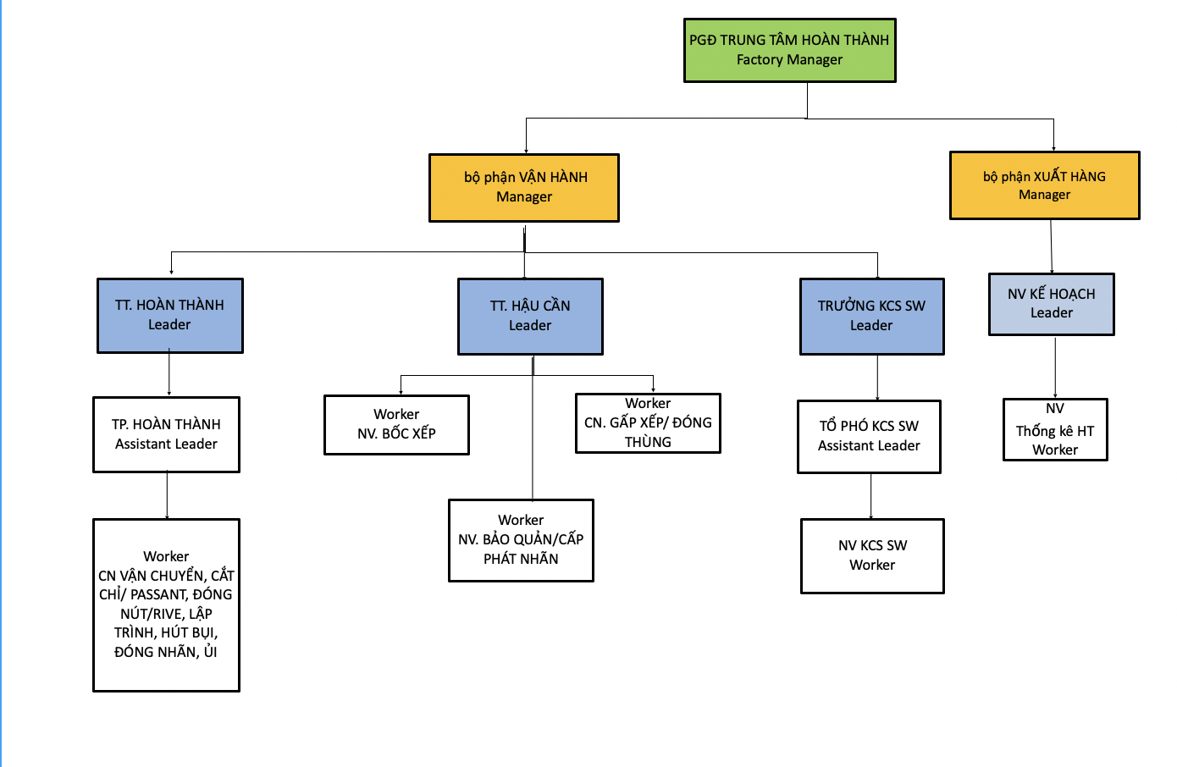

4.2 Session Flowchart Diagram
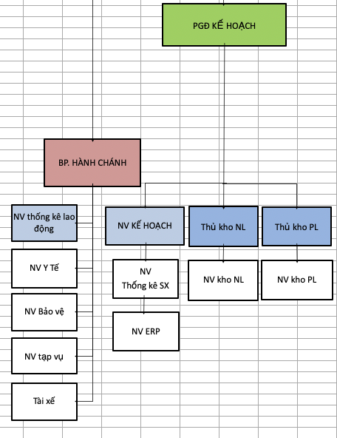
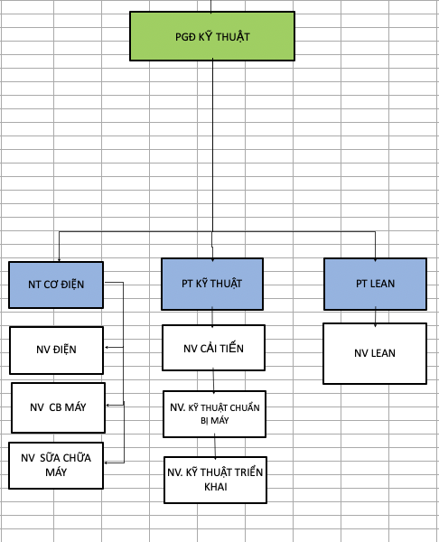
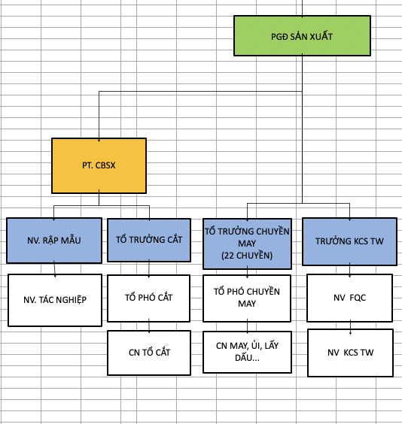
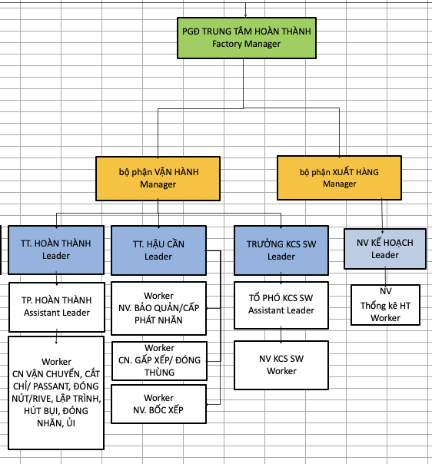

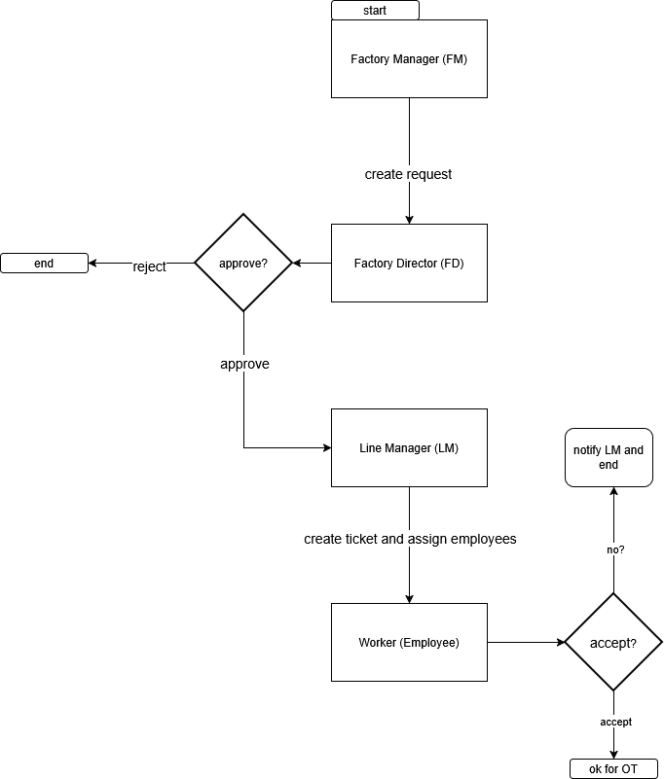

Chapter 5. Use Case
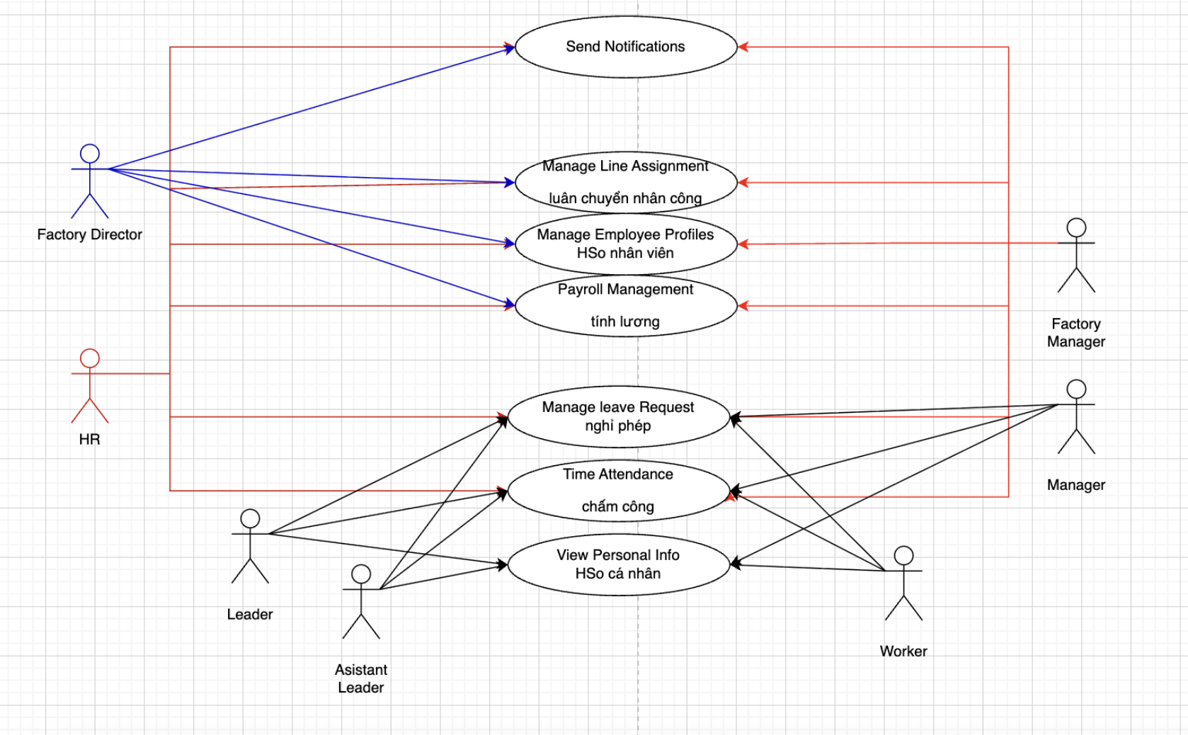

Chapter 6. DFD Diagram

6.1 Context DFD
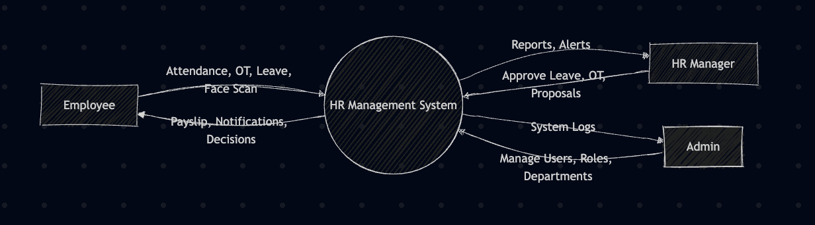

6.2 DFD Level 1
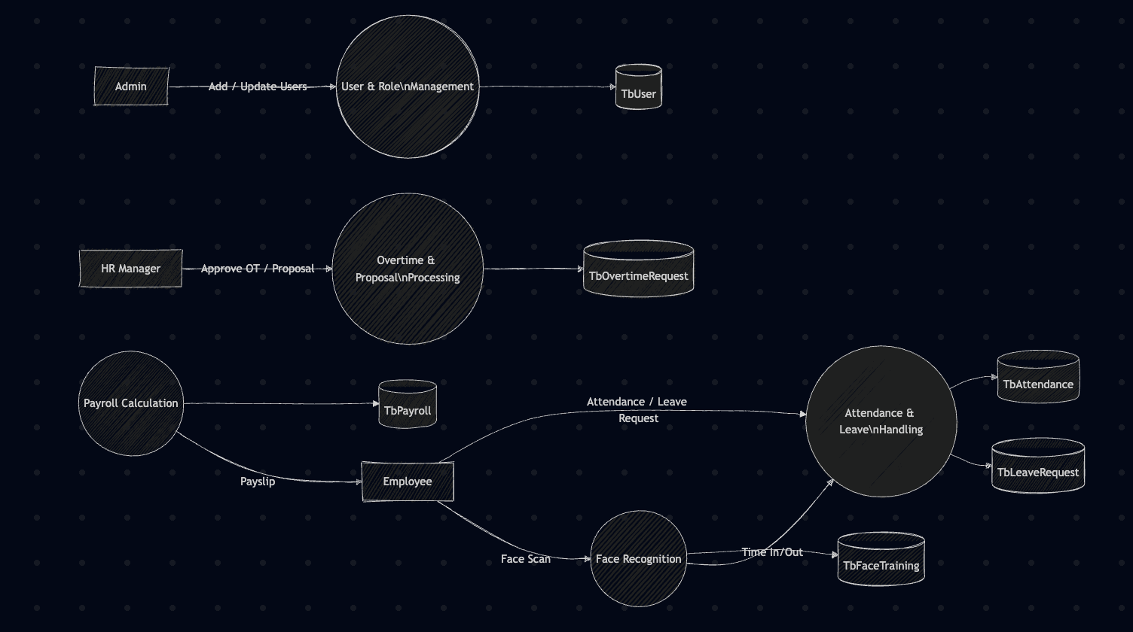

6.3 DFD Level 2
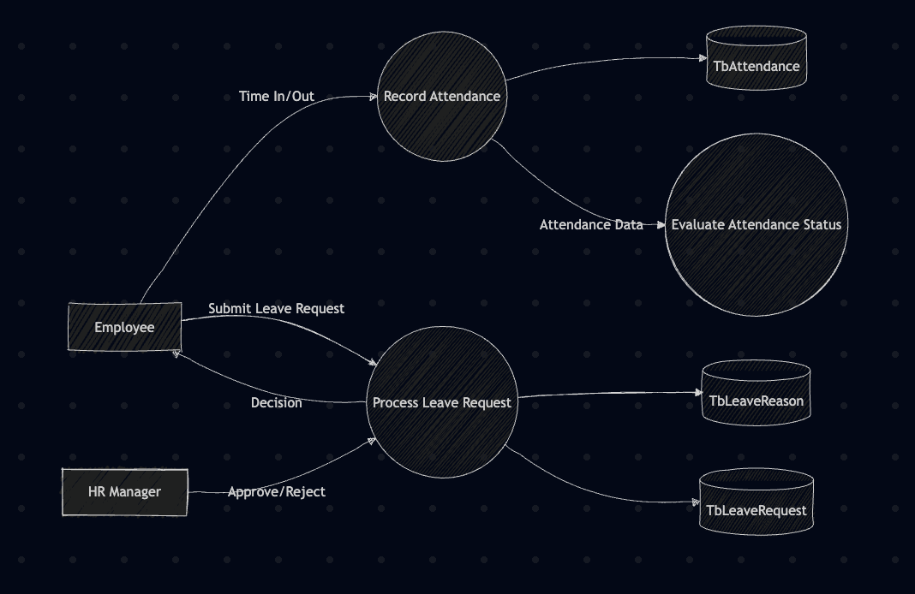
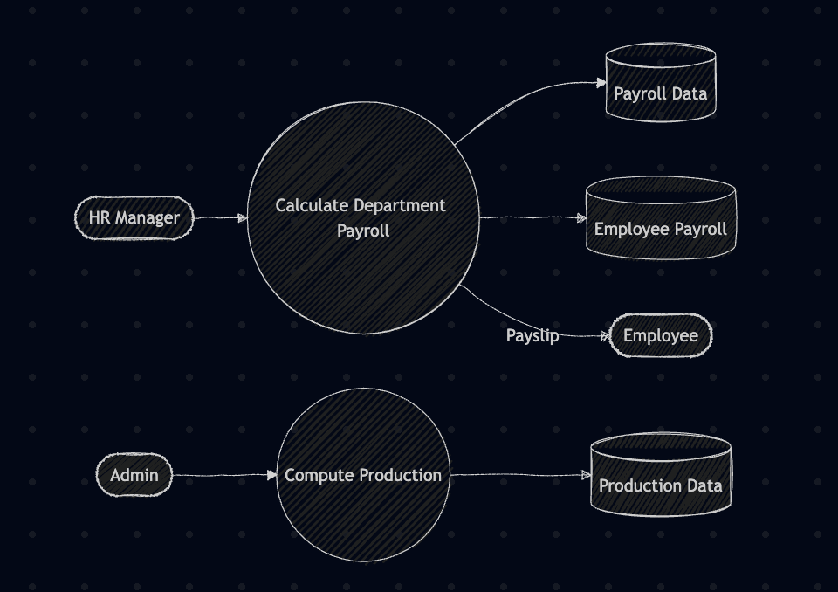
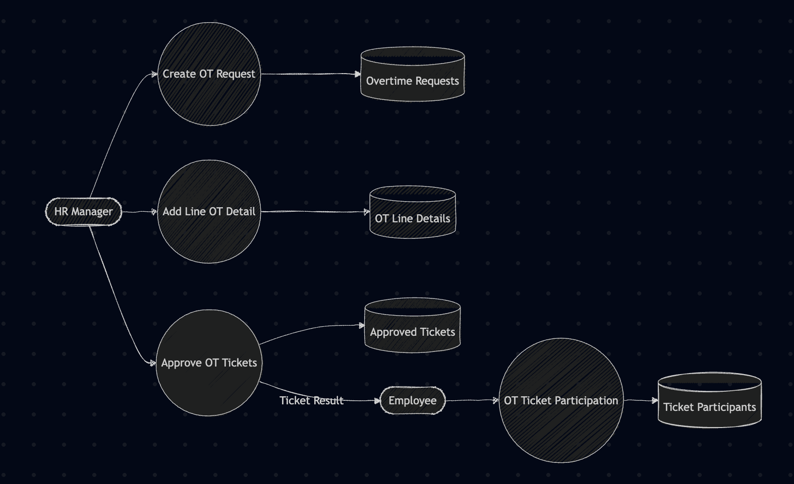

Task Sheet Review 2

Project Ref No. |  | Project Title | Activity Plan Prepared by | Date of preparation of Activity Plan
Sr. No. | Task |  |  | Actual Start Date | Actual Days | Teammate Names | Status
1 | Data flow diagram (DFD) | MayPayHR | Tu, Tien, Nhi, Phu | 25/11/2025 | 5 days | Nhi, Tien | Completed
2 | Database Design |  |  | 18/11/2025 | 3 days | Tu, Phu | Completed
3 | Table Design |  |  | 18/11/2025 | 7 days | Nhi | Completed
4 | Flowchart |  |  | 25/11/2025 | 7 days | Tu | Completed
5 | Use Case |  |  | 19/11/2025 | 3 days | Tu | Completed
6 | Task Sheet 2 |  |  | 25/11/2025 | 2 days | Nhi | Completed

Task Sheet Review 3

Sr. No. | Task | Actual Start Date | Actual Days | Teammate Names | Status
1 | Time Attendance – Face Enrollment (HR) - HR upload face data (POST /user/face-data) - Validate image quality (face detected = true) - Update User.face_data - Notify employee | 18/11/2025 | 30 days | Tien | Completed
2 | Time Attendance – Daily Sync Job - Auto-sync offline attendance (cron job) - Retry failed sync - Log sync history (GET /attendance/sync-log) - Notify HR on repeated failures | 18/11/2025 | 30 days | Tien | Completed
3 | Time Attendance – Late Report Generator - Get all late attendance per department - Categorize reasons - Export Excel (GET /attendance/late-report?month=) - Auto-send to HR email | 18/11/2025 | 30 days | Tien | Completed
4 | Time Attendance – Mobile Check-In (Optional) - Allow mobile face-scan with location - Validate GPS radius - Save AttendanceMobile - Notify Manager for approval | 18/11/2025 | 30 days | Tien | Completed
5 | Time Attendance – Monthly Summary Dashboard - Chart of Present / Late / Leave / OT - Filter by team/department - Redis cache refresh every 1 hour - Export snapshot | 18/11/2025 | 30 days | Tien | Completed
6 | Payroll – Auto Calculate Daily Salary Rate - Pull base_salary from User - Calculate per-hour/per-day rate - Save to PayrollRate table - Notify Payroll team | 18/11/2025 | 30 days | Tu | Completed
7 | Payroll – Merge Overtime Into Payroll - Aggregate Approved OvertimeTicket - Apply OT multiplier - Update PayrollDetail - Notify Director | 18/11/2025 | 30 days | Tu | Completed
8 | Payroll – Deduct Leave Days - Pull approved leaves - Deduct unpaid leave - Recompute net salary - Update PayrollHistory | 18/11/2025 | 30 days | Tu | Completed
9 | Payroll – Publish Payslip (Employee Self-Service) - Generate payslip by employee - Allow download PDF - Track viewed/unviewed status - Notify via app | 18/11/2025 | 30 days | Tu | Completed
10 | Payroll – Yearly Payroll Summary (HR) - Report by month/year - Include bonus, OT, leave deductions - Export Excel/PDF - Notify HR automation queue | 18/11/2025 | 30 days | Tu | Completed
11 | Overtime – Request Overtime Assignment (Factory Manager) - Create overtime request, check available staff (GET /user/available) - Save OvertimeRequest (status = pending), notify Manager | 18/11/2025 | 30 days | Phu | Completed
12 | Overtime – Create Overtime Ticket (Manager) - Build ticket from request or new - Select employees, validate not on leave (GET /leave/requests) - Save OvertimeTicket, notify Factory Manager | 18/11/2025 | 30 days | Phu | Completed
13 | Overtime – Confirm Overtime Ticket (Factory Manager) - Review tickets, confirm/reject (PUT /assignment/confirm-overtime/{ticket_id}) - Update status → confirmed/rejected | 18/11/2025 | 30 days | Phu | Completed
14 | Firebase Cloud Message Integration – Send push notifications to Employees upon being assigned overtime works. Employees can click this notification to navigate to the assignment immediately | 18/11/2025 | 30 days | Phu | Completed
15 | Flutter app for Employees to either accept or reject overtime work assignment – A flutter app that show overtime assignments | 18/11/2025 | 30 days | Phu | Completed
16 | Proposal – Propose Salary Increase - Factory Manager proposes salary (checks 12-month rule) - Save Proposal (type=salary), notify Director | 18/11/2025 | 30 days | Nhi | Completed
17 | Proposal – Propose Position Change - Propose new role/department/salary (type=position) - Notify Director | 18/11/2025 | 30 days | Nhi | Completed
18 | Proposal – Propose Skill Level Change - Manager proposes skill-level change (type=skill) - On approval auto-create related salary proposal | 18/11/2025 | 30 days | Nhi | Completed
19 | Proposal – Approve Proposals (Factory Director) - Director reviews proposals, approve/reject (PUT /assignment/approve/{proposal_id}) - If approved, notify HR & Payroll to update User.base_salary | 18/11/2025 | 30 days | Nhi | Completed
20 | Proposal – Proposal History & Log - Track proposal changes - Save ProposalHistory records - Notify Managers on final approval | 18/11/2025 | 30 days | Nhi | Completed

